**DAILY ONLINE ACTIVITIES SUMMARY**

|  |  |  |  |  |  |  |  |
| --- | --- | --- | --- | --- | --- | --- | --- |
| **Date:** | **27/05/2020** | | | | **Name:** | **Tushit Shukla** | |
| **Sem & Sec** | **4 sem & B sec** | | | | **USN:** | **4AL18CS093** | |
| **Online Test Summary** | | | | | | | |
| **Subject** | | **OCC IA Test** | | | | | |
| **Max. Marks** | | **30** | | **Score** | | **27** | |
| **Certification Course Summary** | | | | | | | |
| **Course** | 1. [Introduction to Cyber security](https://olympus.greatlearning.in/courses/12628) | | | | | | |
| **Certificate Provider** | | | **Great Learning** | **Duration** | | | **1s hr(spent by me on that day to learn)** |
| **Coding Challenges** | | | | | | | |
| **Problem Statement:**  1. In Bubble sort, each pass consists of comparison each element in the file with its successor (i.e. x[i] with x[i+1]) and interchanging two elements if they are not in the proper order. The array may be sorted in any pass. If the array is sorted, then remaining passes should be skipped off. Write a C Program to sort an array of integers in ascending order and display the sorted array and Number of passes performed for sorting. | | | | | | | |
| **Status: Completed** | | | | | | | |
| **Uploaded the report in Github** | | | | **Yes** | | | |
| **If yes Repository name** | | | | <https://github.com/tushitshukla29/lockdown-program> | | | |
| **Uploaded the report in slack** | | | | **Yes** | | | |

**Online Test Details**

OCC TEST Details:

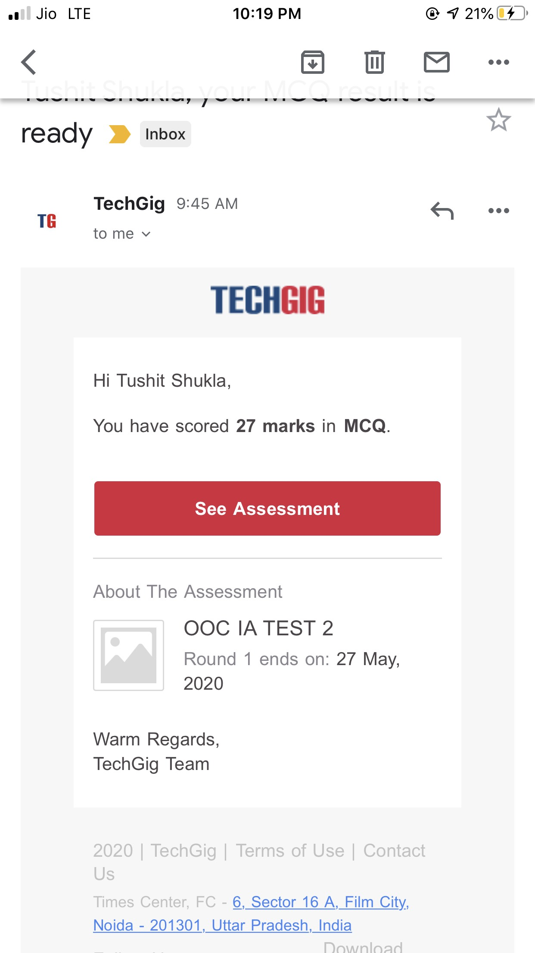

**Online Certification Details**:



**Coding Challenge Detail :** I have written programs and uploaded it to my Github repository.

Link as follows: 1. <https://github.com/tushitshukla29/lockdown-program/blob/master/bubble%20sort>